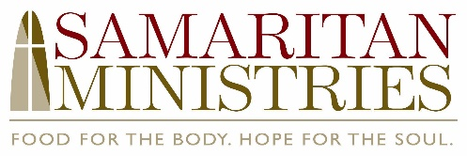

FOR IMMEDIATE RELEASE
News media contact
Steve Bumgarner
Capture Public Relations & Marketing
336.722.9660 or steve@capturevalue.com

High School Reunion’s Christmas Vacation Returns
to the Ramkat December 12
Ticket proceeds to benefit Samaritan Ministries

WINSTON-SALEM, NC (OCT. 21, 2025) — High School Reunion, a Winston-Salem based band, is returning to The Ramkat on Friday, December 12, 2025 for its second annual Christmas Vacation extravaganza. Doors will open at 7 p.m. and the show will begin at 8 p.m. A portion of the proceeds from ticket sales will benefit Samaritan Ministries. In addition, there will be various other opportunities to support Samaritan Ministries during the show. Tickets can be purchased at TheRamkat.com.

Channeling Clark Griswold’s indomitable holiday energy, High School Reunion’s Christmas Vacation includes two sets of music: one set of popular throwback holiday songs and an extended set of High School Reunion classic covers and crowd-pleasers. To get into the spirit of the season, attendees are encouraged to wear their favorite ugly Christmas sweaters and/or clothes inspired by the movie “Christmas Vacation.”

About High School Reunion
Covering high energy rock/pop classics from the 80s, 90s, and 00s, High School Reunion conjures memories of simpler times—just like a high school reunion. Based in Winston-Salem, the band made its public debut in November 2021 and has since built a loyal following and a reputation for bringing the party all the time, every time! High School Reunion has appeared at numerous events in the Triad including Fiddlin’ Fish’s annual throwback prom party, the Gears & Guitars festival, the Carolina Classic Fair, and High Point’s Stock + Grain Assembly.

About Samaritan Ministries
Founded in 1981, Samaritan Ministries is an interdenominational, volunteer-based Christian ministry that serves Winston-Salem and Forsyth County. The Samaritan Ministries Soup Kitchen and Samaritan Inn Shelter are open 365 days and nights a year to serve people in need. In 2024, the Soup Kitchen served 128,469, warm meals, and the Samaritan Inn provided shelter to 468 different homeless men. Samaritan Ministries is located at 414 East Northwest Boulevard near downtown Winston-Salem. For more information about Samaritan Ministries, please visit samaritanforsyth.org.

# # #

