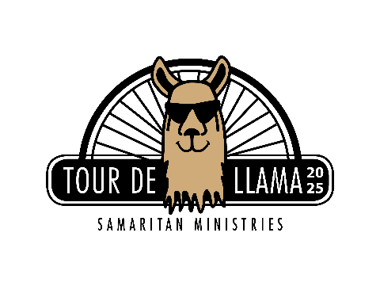

FOR IMMEDIATE RELEASE

News media contact

Jan Kelly, Executive Director

336-448-2665 (direct)

[jan.kelly@samaritanforsyth.org](mailto:jan.kelly@samaritanforsyth.org)

Samaritan Ministries to Host 11th Annual

Tour de Llama on June 21, 2025

WINSTON-SALEM, NC (**MAY 14, 2025**) — Samaritan Ministries will host its 11th annual Tour de Llama bike ride and fundraiser at Divine Llama Vineyards in East Bend on Saturday, June 21. All proceeds raised through rider registrations and sponsorships will help Samaritan Ministries fulfill its mission of providing food, shelter and hope through Christian love. Samaritan Ministries’ goal this year is to raise $45,000. For every dollar raised, 85¢ goes directly toward guest services.

Riders can choose 21-, 38-, and 60-mile routes through rural Yadkin County. All rides will begin at 8:30 a.m. After their rides, riders and attendees (families and friends) are welcome to stay at Divine Llama for food trucks, wine tasting and, of course, seeing the llamas.

The registration fee per rider is $40, and participants must be at least 18 years old. Registration is available at [samaritanforsyth.org/tour-de-llama-event](https://www.samaritanforsyth.org/tour-de-llama-event/) and must be completed by 3 p.m. on Thursday, June 19. All cyclists must pre-register and complete the required online waiver forms before the cutoff date.

“While most of us think about summer vacations and spending time with our families, our guests remain in crisis during these hot, humid months. Summer heat drains our guests and puts them at risk of dehydration, heat stroke and sunburn,” said Jan Kelly, Samaritan Ministries Executive Director. “Our shelter is full, and we see more families with children in the Soup Kitchen during the summer. It’s so encouraging to see the cycling community come together to make a difference for people in need.”

Arbor Investment Advisors is the presenting sponsor of the event. In addition, Ken’s Bike Shop, Divine Llama Vineyards and several other partners make this event possible. Sponsorships are available in four tier levels: Platinum, Gold, Silver, and Bronze. For more information visit [samaritanforsyth.org](https://www.samaritanforsyth.org/tour-de-llama-event/), or contact Robin Stone at 336-448-2668 or [robin.stone@samaritanforsyth.org](mailto:robin.stone@samaritanforsyth.org).

**About Samaritan Ministries**

Founded in 1981, Samaritan Ministries is an interdenominational, volunteer-based Christian ministry that serves Winston-Salem and Forsyth County. The Samaritan Ministries Soup Kitchen and Samaritan Inn Shelter are open 365 days and nights a year to serve people in need. Samaritan Ministries is located at 414 East Northwest Boulevard near downtown Winston-Salem. For more information about Samaritan Ministries, please visit [samaritanforsyth.org](https://www.samaritanforsyth.org/).

