Be a part of Samaritan Ministries’
Season of Sharing
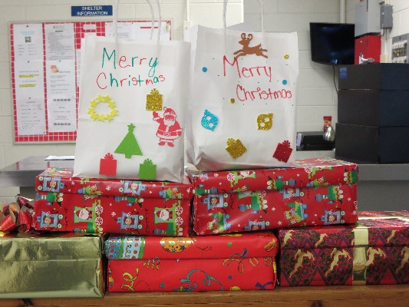

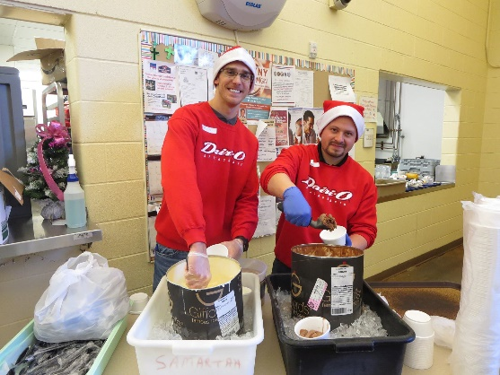
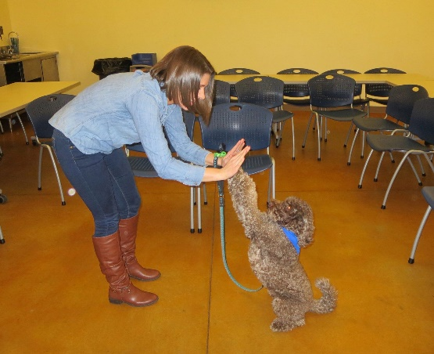

November 19, 2018 to January 1, 2019

Use your time, talents and treasure to brighten the season for Samaritan Soup Kitchen and shelter guests.
  - Sing or perform for Soup Kitchen guests
  - Organize a children’s group to make holiday placemats or centerpieces
  - Honor someone by serving in the Soup Kitchen or shelter
  - Prepare a favorite holiday treat or meal for shelter guests
  - Help decorate our building, inside and out
  - Collect items from wish list for Christmas gift bags
  - Have another idea? We want to hear from you!
To discuss a project or schedule a date, visit samaritanforsyth.org/volunteerreg and click Special Project Request (at the top of the page).
Or contact Alex Jarrell at alex.jarrell@samaritanforsyth.org or 336-448-2668

